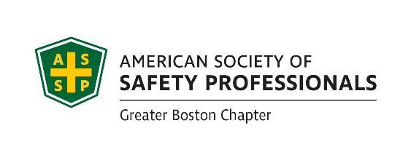
April 5th, 2021 Executive Board Meeting
Attendance:
Michael Sample, Dave Crowley, Don Delikat, Peter Turner, Maura Craig, Jeff Myung, Scott Ray, Cesar Morocho, Tom Bochart, Shawna Fraser, Rich O’Keeffe, Brian Hanlon, Eugena Kennedy,

Scholarships - Brian

Elections – Scott
- Nomination for Shawna Fraiser to fulfill the role of secretary in 2021-2022
- Nomination for Pete Turner to fulfill the role of president in 2021-2022

Financial report – Eugenia

Tech Meeting update – Jeff

Student chapter – Cesar mentioned the Virtual Occupational Health & Safety Research Retreat
- The Student Section of the ASSP Greater Boston Chapter and the Center for the Promotion of Health in the New England Workplace (CPH-NEW) are organizing a virtual Occupational Health and Safety research retreat via Zoom on Thursday, May 13th, 2021 (1:00-4:00 pm).

Science Fair – Mike Sample
- MA Science Fair- Mike informed the Fair we would like to support them with $1000 to recognize 5 students with $200 each for incorporating safety into their project.
- Waiting to hear back. Eleanor A. Tishler, Vice President of Corporate Development Has retired, so we are forming new contacts

Newsletter – Open
- we are due to publish a Newsletter
Ask each Chair to submit short articles, That should make the task a little easier.

Student Chapter – Mike or Don

Recognition – Scott

New business – All
- Maura asked for her last name to be updated to Craig on the web site
- Mike Sample-That is why I propose earmarking funds for the Emerging Professionals and WISE groups. I feel we can sponsor meet & greets in fun settings, led by other younger professionals
  - Red sox game
- Bowling
- Karting
- Axe throwing
NOTE: The options are limitless (post-Covid) and that initiative might draw future leaders into the chapter.

Meeting Adjourned at 4:45PM

