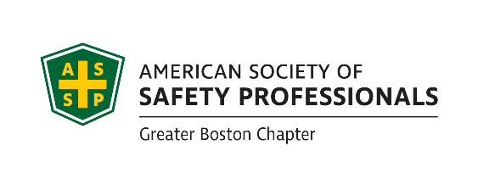
June 28th, 2021 Executive Board Meeting
Attendance:
Michael Sample, Dave Crowley, Don Delikat, Peter Turner, Maura Craig, Jeff Myung, Scott Ray, Cesar Morocho, Tom Bochart, Rich O’Keeffe, Brian Hanlon, Eugena Kennedy,

Scholarships - Brian

New Leadership – Scott
- Welcome Shawna Fraser to fulfill the role of secretary in 2021-2022
- Welcome to Pete Turner to fulfill the role of president in 2021-2022

Financial report – Eugenia

Tech Meeting update – Jeff

Student chapter – Cesar mentioned the Virtual Occupational Health & Safety Research Retreat
- The Student Section of the ASSP Greater Boston Chapter and the Center for the Promotion of Health in the New England Workplace (CPH-NEW) are organizing a virtual Occupational Health and Safety research retreat via Zoom on Thursday, May 13th, 2021 (1:00-4:00 pm).

Science Fair – Mike Sample

Newsletter – Open
- we are due to publish a Newsletter Bean Pot
Ask each Chair to submit short articles, That should make the task a little easier.

Student Chapter – Don

Recognition – Scott

New business – All
- Maura asked for to connect new job openings to social media, also her her last name to be update to Craig on the web site has been accomplished.
- Pete discussed a potential in person meeting at Sam Adams or another location with outdoor dinning sometime in August-TBD
- Mike Sample reported that Granite State Chapter is hosting a Car Show fund raiser, the event is open to all makes of cars, trucks and motorcycles. Date is 8-21-21 11-2pm contact Joe Orazio at ksc328@gmail.com for more information.

Meeting Adjourned at 4:50PM

